# Predic on Of Full Load Electrical Power Output Of A Base Load Operated Combined Cycle Power Plant Using IBM Watson

**Team Members**

1. **Ananya Mahapatra - 19BAI10061**
2. **Sahil Ghule - 19BAI10076**
3. **Rishi Rajpal - 19BCY10027**
4. **Pranjal Roy - 19BAI10008**

## 1 INTRODUCTION

### 1.1 Overview

This Project examines and compares some machine learning regression methods to develop a predic ve model, which can predict hourly full load electrical power output of a combined cycle power plant. The base load opera on of a power plant is influenced by four main parameters, which are used as input variables in the dataset, such as ambient temperature, atmospheric pressure, rela ve humidity, and exhaust steam pressure. These parameters affect electrical power output, which is considered as the target variable. A web applica on is built to enter the inputs and view the result.

**1.2 Purpose**

The Combined Cycle Power Plant or combined cycle gas turbine, a gas turbine generator generates electricity and waste heat is used to make steam to generate addi onal electricity via a steam turbine. The gas turbine is one of the most efficient one for the conversion of gas fuels to mechanical power or electricity. Combined cycle power plants are frequently used for power produc on. These days predic on of power plant output based on opera ng parameters is a major concern.

Using this we predict the full load electrical power output of a base load power plant is important in order to maximize the profit from the available megawa /hour.

## 2 LITERATURE SURVEY

### 2.1 Exis ng problem

Single-cycle gas turbine power plants generate electricity by using natural gas and compressed air. Air is drawn from the surroundings, compressed, and fed into the combustion chamber of the gas turbine. Here, natural gas is injected which mixes with the compressed air and ignited. The combustion produces a high-pressure, hot gas stream that flows through the turbine causing it to spin (at tremendous speeds). Consequently, this spins a generator which is connected to the turbine to produce electricity.

For single-cycle gas turbines, much of the energy is wasted as hot exhaust achieving an energy conversion efficiency of 35% at best. Combined cycle power plants exploit this inefficiency by capturing the waste heat using a heat recovery steam generator (HRSG), to produce even more power.

### 2.2 Proposed Solu on

Combined cycle power plants are power generation plants that use both gas and steam turbines together to generate electricity. The waste heat generated from the gas turbine is used to produce steam which is fed to a steam turbine to generate even more electricity. This increases the power produced (up to 50% more) for the same amount of fuel, as well as increases the plant’s efficiency to about 60%.

The Output power of the Combined Cycle Power Plant (CCPP) is dependent on a few parameters which are atmospheric pressure, exhaust steam pressure, ambient temperature, and relative humidity. Being able to predict the full load electrical power output is important for the efficient and economic operation of the power plant.

## 3 THEORETICAL ANALYSIS

### 3.1 Block Diagram

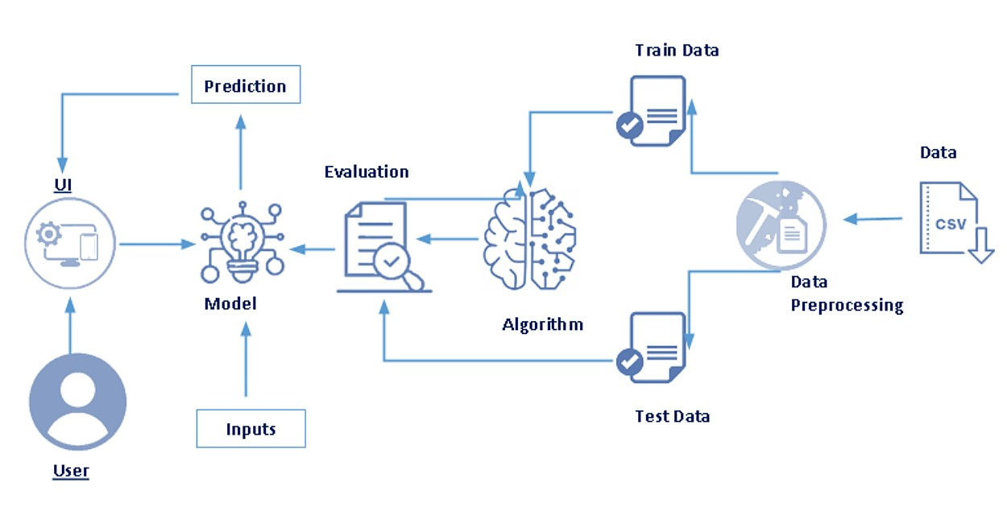

### 3.2 Hardware/ So ware requirement

1. Jupyter Notebook
2. Spyder
3. Visual studios
4. IBM Cloud
   1. IBM Watson studios
5. Flask
6. Packages:
   1. Pandas
   2. numpy
   3. scikit -learn
   4. matplotlib & seaborn
   5. Pickle

## 4 EXPERIMENTAL INVESTIGATIONS

1. The dataset which is used for building model is collected from a Combined Cycle Power Plant over 6 years (2006-2011).
2. The dataset contains 9568 datapoints.
3. We first build a model in jupyter notebook.
4. The data is split into training and tes ng set in 8:2 ra o.
5. The model is trained using Mul ple regressor, Decision tree classifier and Random forest.
6. Random forest yields the most accurate result.
7. Then we integrate the machine learning model with the flask to build the web applica on.
8. The model is then deployed using IBM Watson Studios.

**Project Workflow:**

* User interacts with the UI (User Interface) to upload the input features.
* Uploaded features/input is analyzed by the model which is integrated.
* Once a model analyses the uploaded inputs, the predic on is showcased on the

UI.

## 5 FLOWCHART

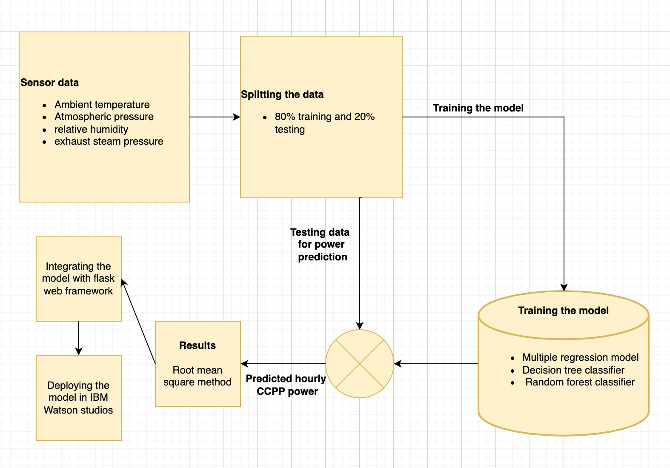

## 6 RESULT

A er implemen ng our proposed model we (or the user) were successfully able to interact with the UI in order to predict the full load electrical power output of a base load power when provided with the informa on of influencing factors like temperature,

Ambient pressure, Rela ve humidity, Exhaust Vaccum.

The predic on is later showcased in the UI.

## 7 ADVANTAGES & DISADVANTAGES

Our model uses random forest algorithm

**Advantages:**

* Random Forest is based on the **bagging** algorithm and uses **Ensemble Learning** technique. It creates as many trees on the subset of the data and combines the output of all the trees. In this way it **reduces overfi ng** problem in decision trees and also **reduces the variance** and therefore **improves the accuracy.**
* **No feature scaling required:** No feature scaling (standardiza on and normaliza on) required in case of Random Forest as it uses rule based approach instead of distance calcula on.
* Random Forest algorithm is very **stable**. Even if a new data point is introduced in the dataset, the overall algorithm is not affected much since the new data may impact one tree, but it is very hard for it to impact all the trees.

**Disadvantages:**

* **Complexity:** Random Forest creates a lot of trees (unlike only one tree in case of decision tree) and combines their outputs. By default, it creates 100 trees in Python sklearn library. To do so, this algorithm requires much more computa onal power and resources. On the other hand decision tree is simple and does not require so much computa onal resources.
* **Longer Training Period:** Random Forest require much more me to train as compared to decision trees as it generates a lot of trees (instead of one tree in case of decision tree) and makes decision on the majority of votes.

## 8 APPLICATIONS

This project can be successfully used in predic ng the full load electrical power output of a base load power plant in order to maximize the profit from the available megawa /hour in case of combined cycle power plant.

## 9 CONCLUSION

Combined cycle power plants create electricity by combining gas and steam engines. The waste heat from the gas turbine is used to generate steam, which is then pumped into a steam turbine to generate even more power. This improves the quantity of electricity produced (up to 50% more) for the same amount of fuel while also increasing the plant's efficiency to around 60%. The project focuses on predicting the full load electrical power output of a base load power plant in order to maximize the profit from the available megawa /hour in case of combined cycle power plant. We achieve this by taking the ambient temperature, atmospheric pressure, rela ve humidity, and exhaust steam pressure as inputs to build the model which will predict the net hourly electrical energy output (EP) of the plant. The dataset is split into 80% training set and 20% tes ng set. The model is then trained using mul ple regressor, decision tree classifier and random forest. The model with random forest yeilds the most accurate predic on with 96.52% accuracy. We integrate the prepared model with flask applica on. Then it is deployed using IBM Watson Studios.

## 10 FUTURE SCOPE

Currently, the applica on needs manual inputs inorder to predict the net hourly electrical energy. So, it can be further integrated and synchronised with the power plant, so the influencing factors such asambient temperature, atmospheric pressure, rela ve humidity, and exhaust steam can be set according to the current environment.

For the future work, other algorithm could be used for the comparison such as Support

Vector Machines (SVM).

## 11 BIBLIOGRAPHY

* h ps://medium.com/analy cs-vidhya/predic on-of-the-output-power-of-a-combinedcycle-power-plant-using-machine-learning-a2ca01848eea
* h ps://www.researchgate.net/publica on/345906727_Predic ng_the_power_of_a_co mbined_cycle_power_plant_using_machine_learning_methods
* h ps://papers.ssrn.com/sol3/papers.cfm?abstract_id=3945086
* h ps://www.sciencedirect.com/topics/engineering/combined-cycle-power-plant
* h ps://www.hindawi.com/journals/wcmc/2021/9966395/
* h p://theprofessionalspoint.blogspot.com/2019/02/advantages-and-disadvantages-ofrandom.html

**APPENDIX**

## a. Source Code

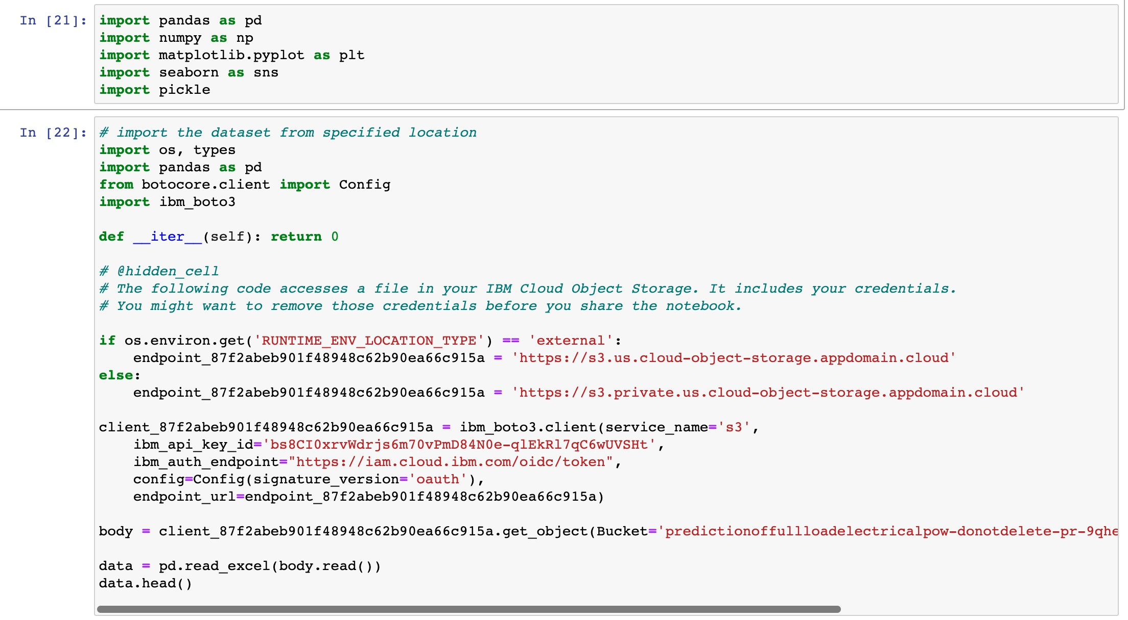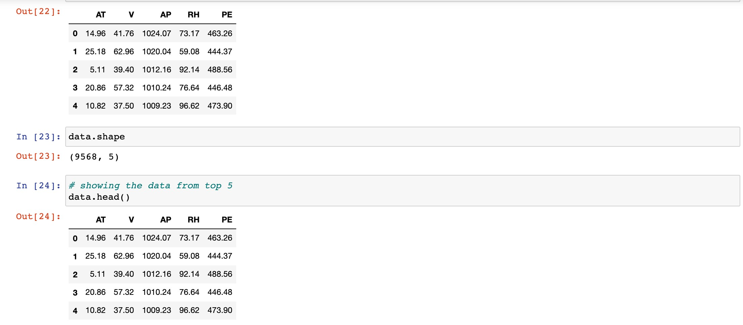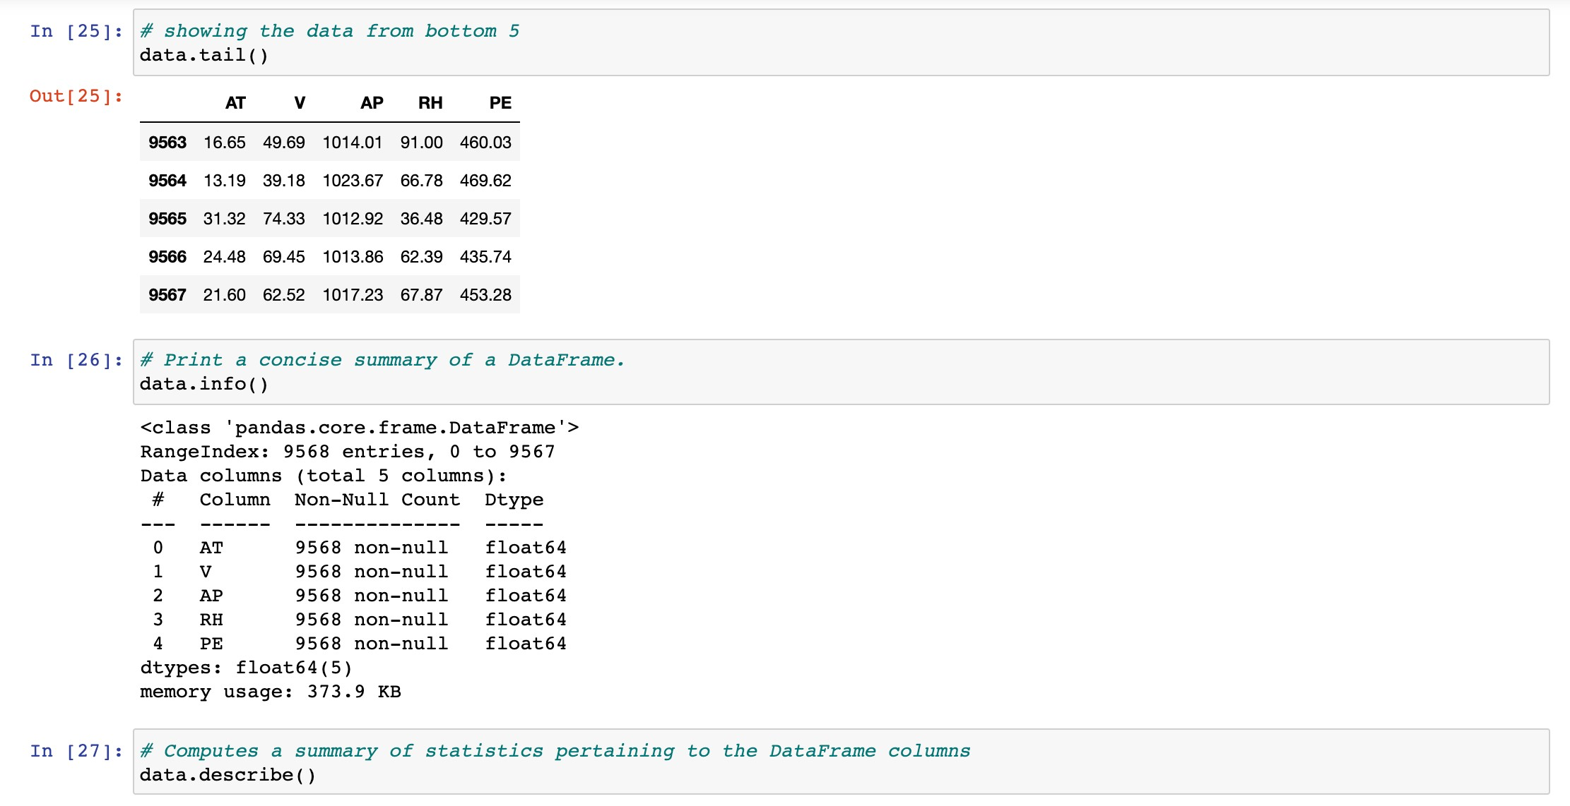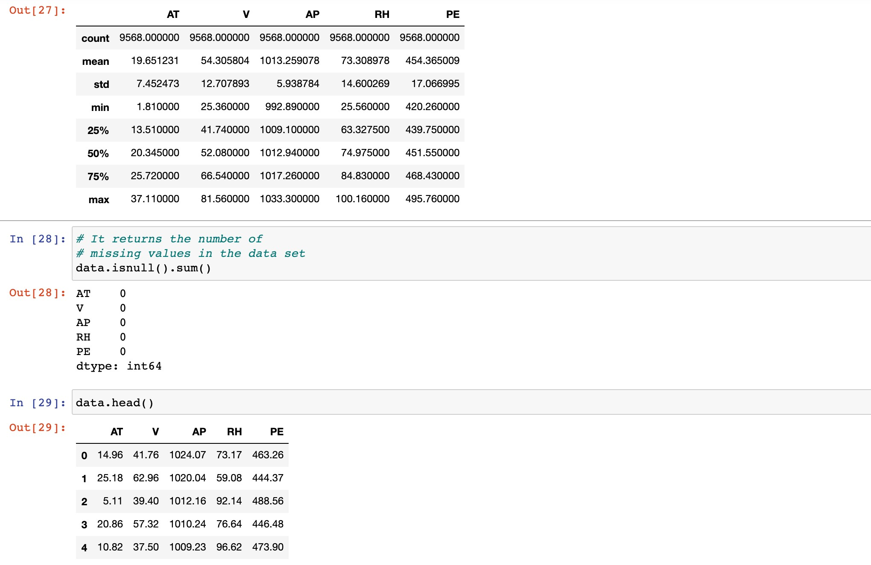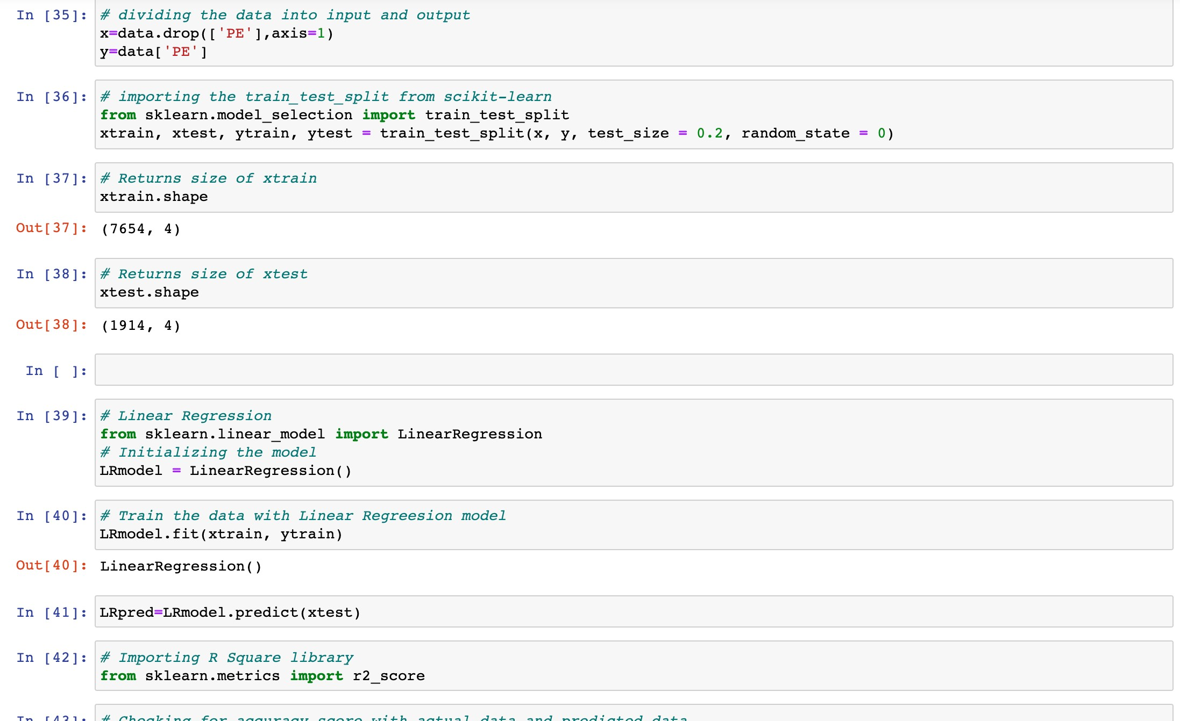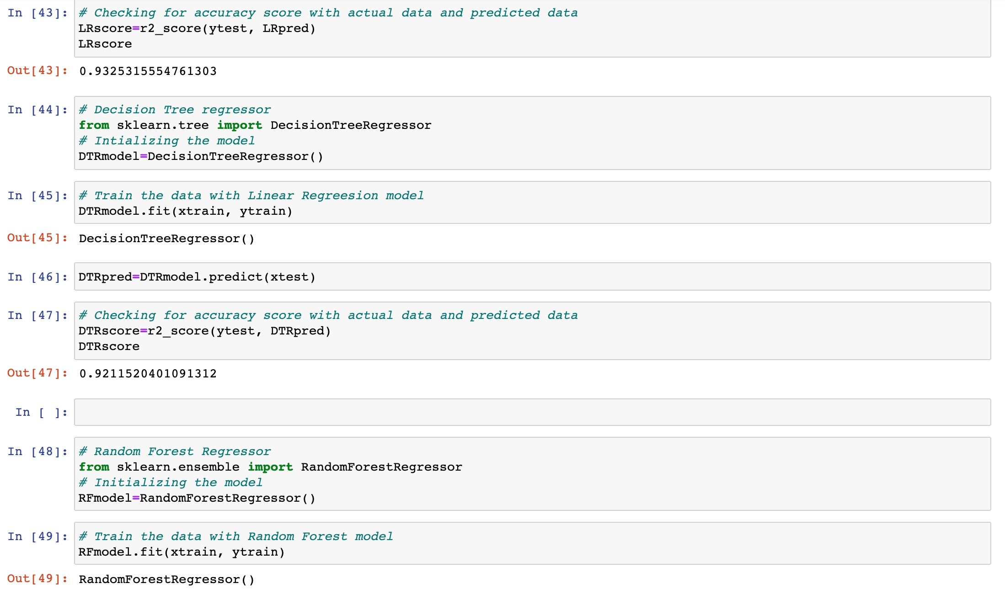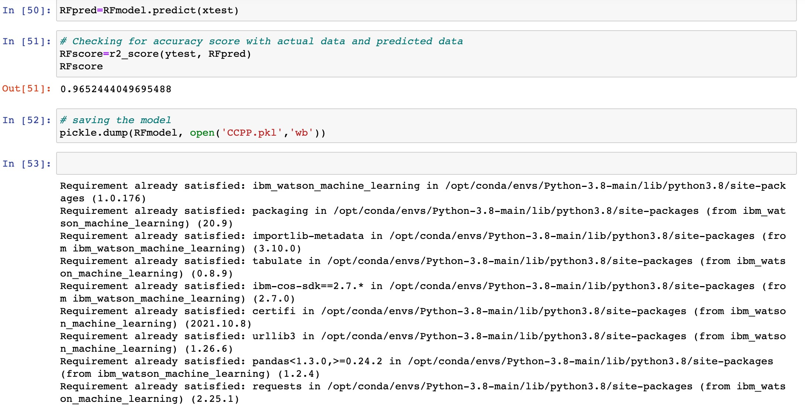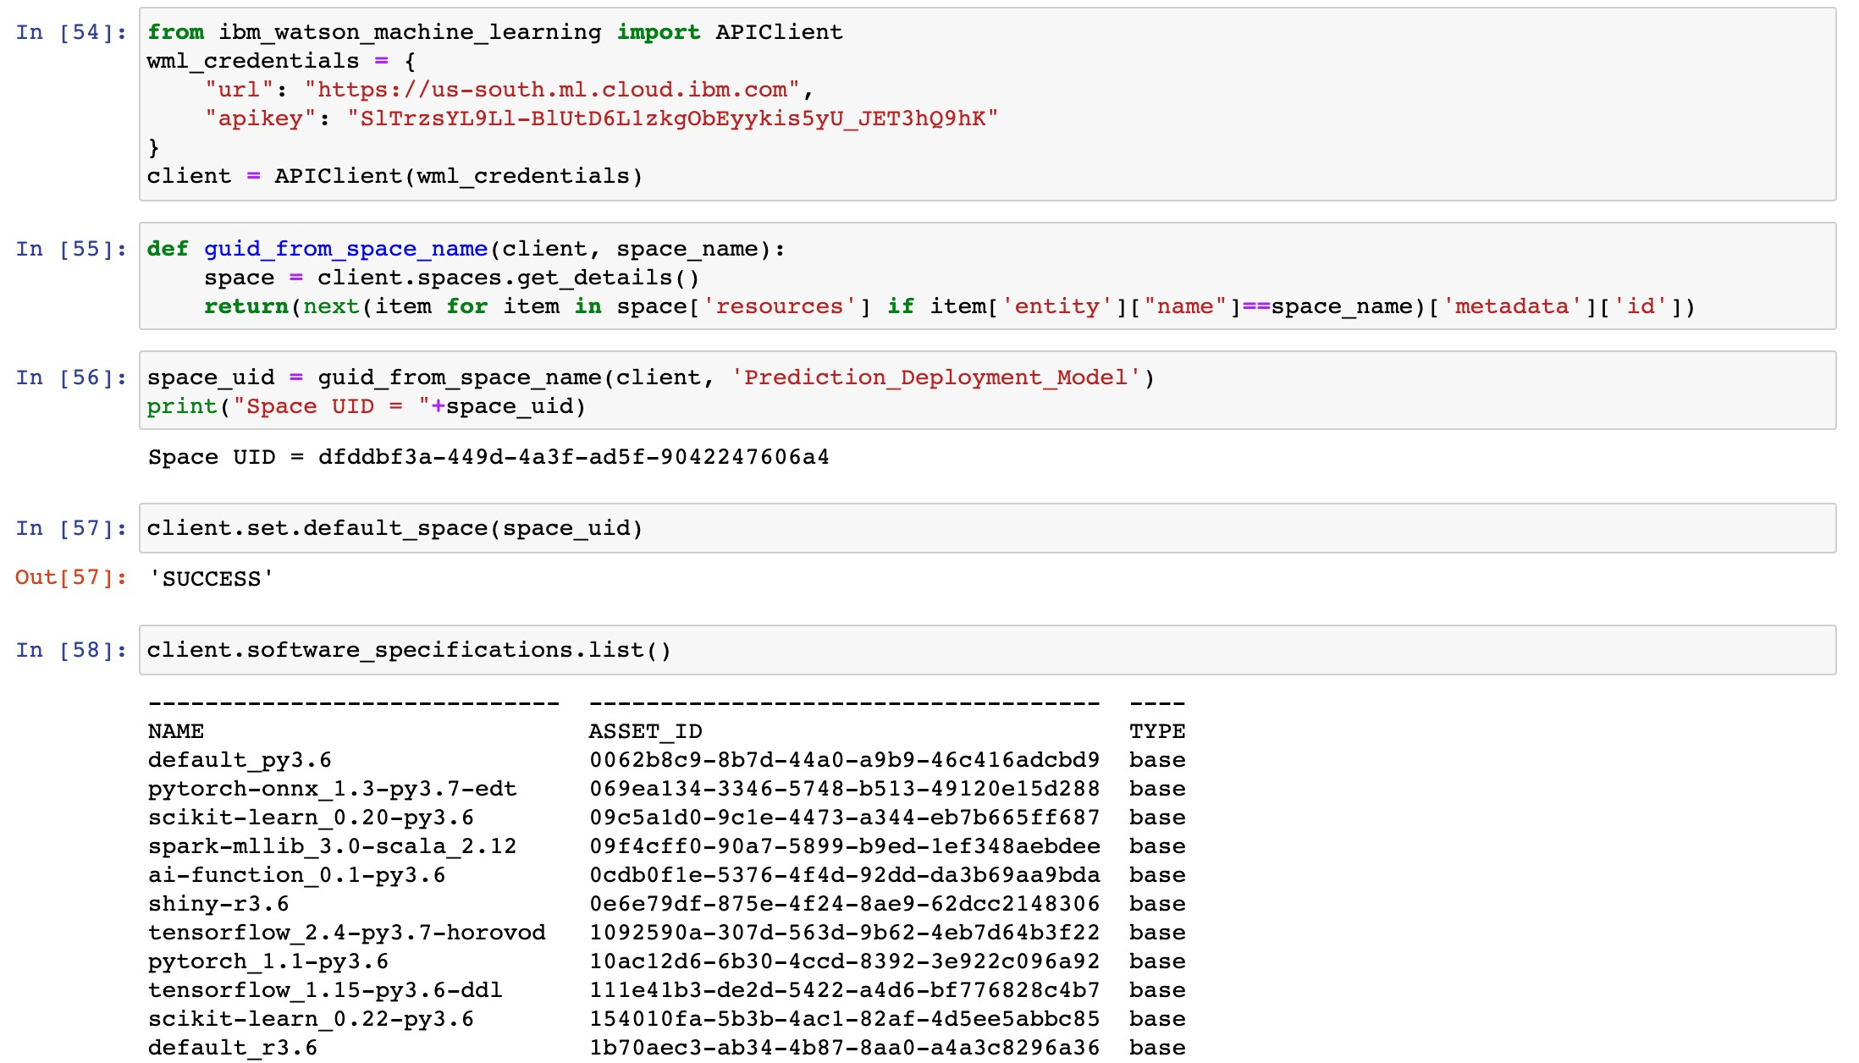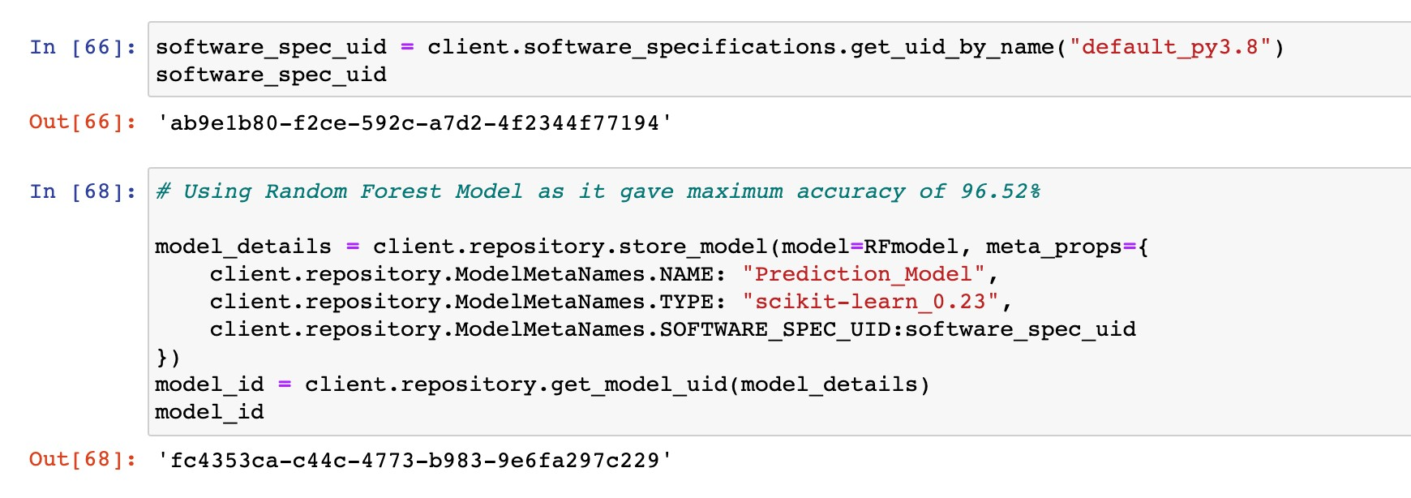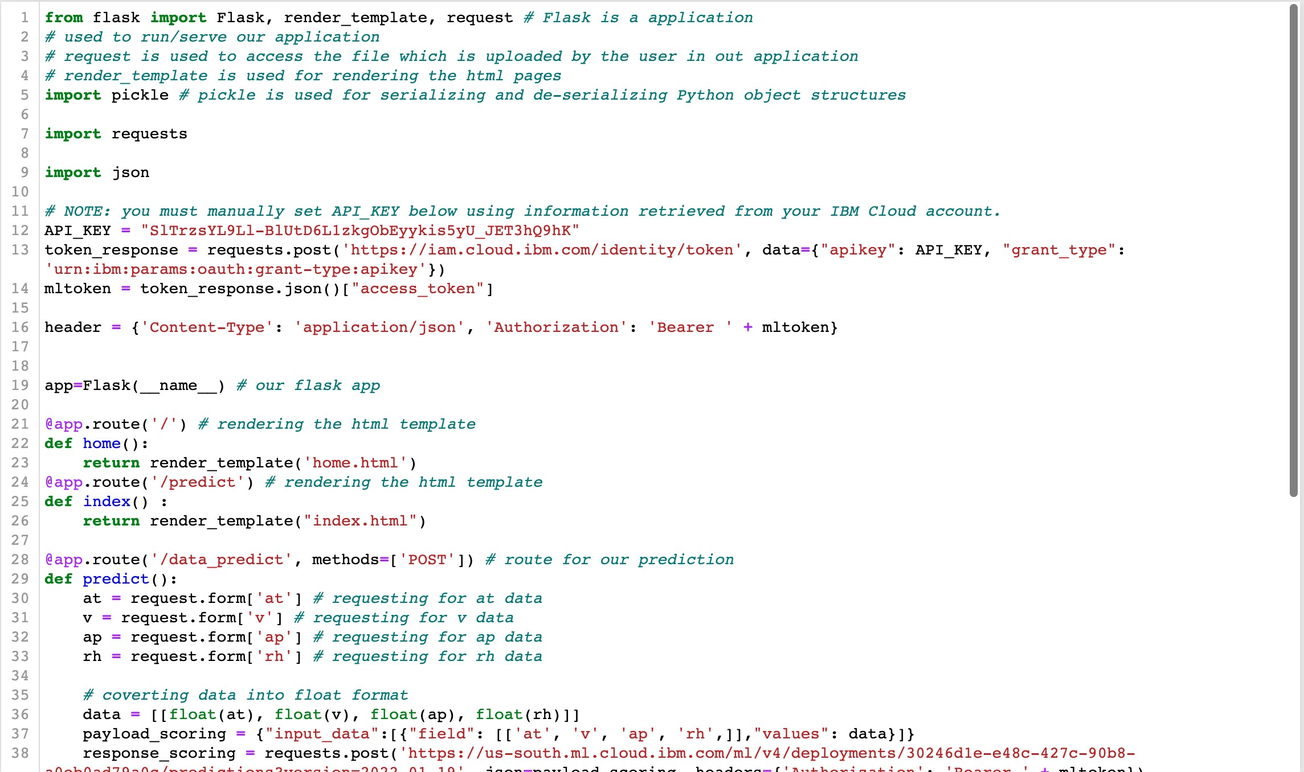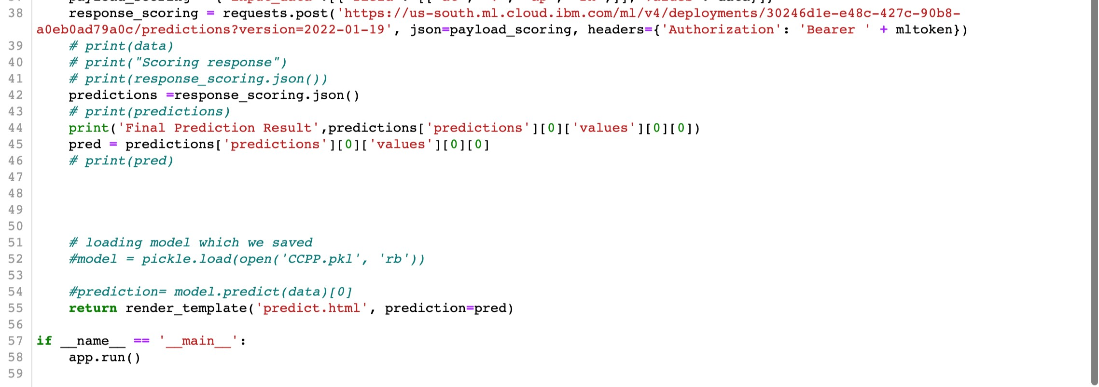

## b. Output screenshot

